

DESIGN AND TECHNOLOGY

HELP-SHEET ON COPYING IMAGES FROM INTERNET PAGES INTO WORD DOCUMENTS

Please note – many images on internet sites are protected by copyright and intellectual property rights. Ensure that you are not performing illegal operations before you copy images or text.

Follow the instructions below and on the next few pages to copy and paste images from internet sites into pages of your own Word documents

INSTRUCTIONS

- Open Word, create a new document and then minimise everything

- Open Explorer, Navigator, or your chosen browser

- Find your site and locate the page with the image you want - the example here is a site on embroidery
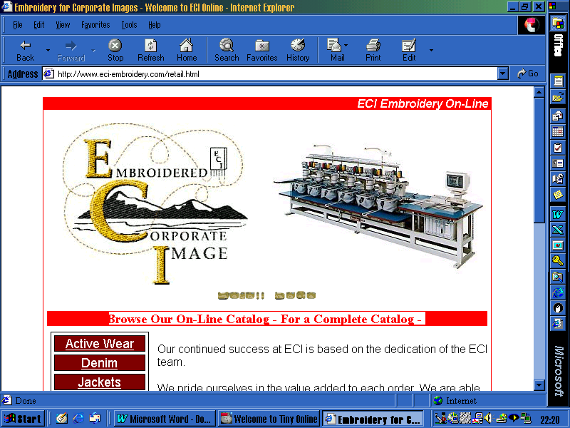
- Right-mouse-click on the image
When you click the right-button of the Mouse, this menu will appear
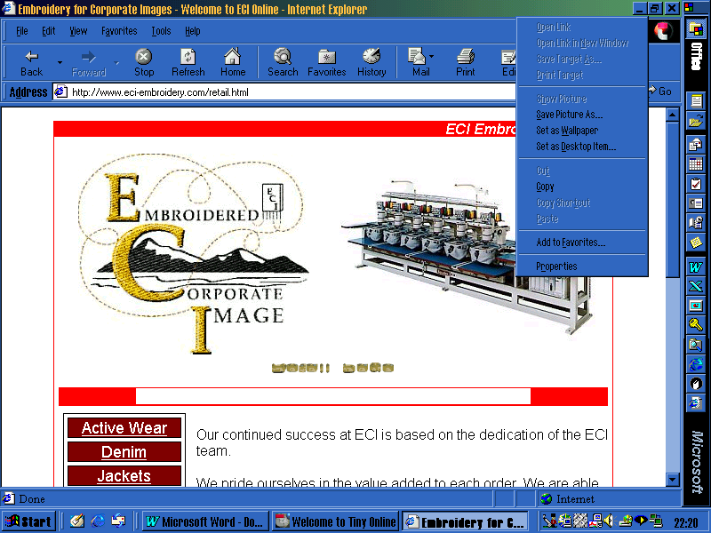
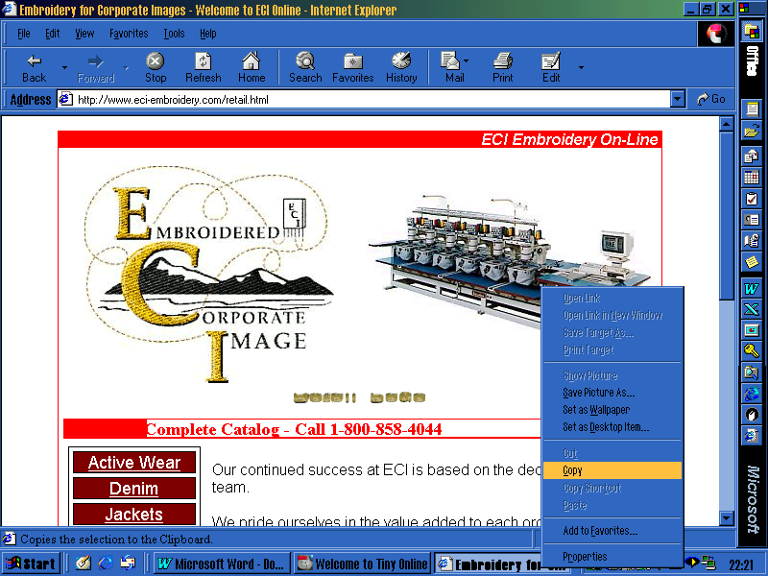
- Select ‘Copy’
Select ‘copy’ with the left-click button to send the image to the computer’s temporary memory – this acts like the ‘copy’-button in Word or any other application

- Minimise the web site and Maximise Word

- When in Word, select ‘Paste’ to put the picture into the document
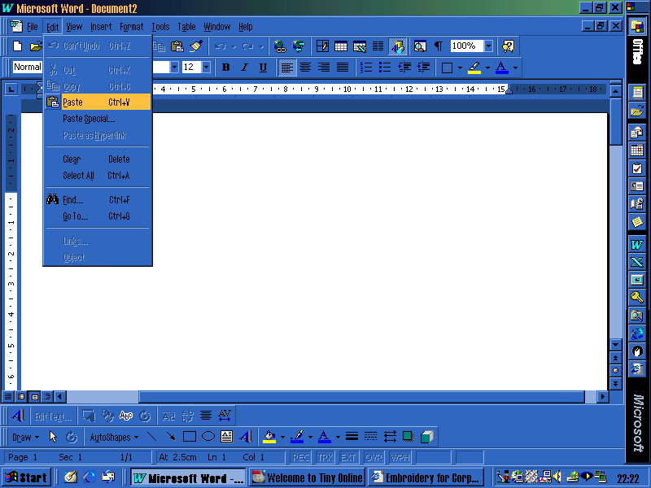

With the picture in Word, you can do as you like with it. You can re-size it, put questions around it using text boxes, or add instructions to it using normal text and text boxes. This help-sheet has been created using these methods.

There are ways of saving the images you encounter on web sites so that you can use them over and over again. The same legal restrictions apply, but with these methods you can import the images into Word documents, PowerPoint presentations and your own web pages.

Here are the instructions without pictures:
- Follow steps 1-4 above
- Left-click on ‘save as’ instead of ‘copy’
- Save the file to your own C or A drive – beware of the file-size, though
- Keep the file in that drive until you need it, then you can use the ‘insert’…’picture’…’from file’ method in Word

