

DRAMA WORKSHEET – IN CONJUNCTION WITH CASE STUDY 3, MODELLING RELATIONSHIPS AND CONTROLLING EVENTS

CHARACTER AND CASTING –
SOAP STARS AND SHAKESPEARE

Task 1

From the pictures on the next few pages, identify the soap characters, and write or type in the space below their main character traits.

Task 2

For the Shakespeare play you are working on, imagine that you are the casting director, and that the characters (NOT THE ACTORS) have applied for the jobs in your play.

Task 3

Give the characters the jobs on the basis of what you know about them and the way you think they can act your parts.

Task 4

Write a brief note of explanation to your production team explaining why each character has been set in role.

Task 5

Compare your answers with those I have started to produce on A Midsummer Night’s Dream.
FROM EASTENDERS

Dot Cotton
Frank Butcher
Grant Mitchell
Ian Beale
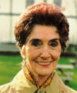




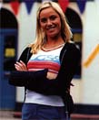






Martin Fowler
Phil Mitchell
Melanie Beale
Pauline Fowler
Jamie Mitchell
Ricky Butcher
Robbie Jackson
Sonia Jackson

FROM CORONATION STREET




Mike Baldwin
Ashley Peacock
Alma Baldwin
Audrey Roberts

Hayley Cropper




Curly Watts
Betty Turpin
The Battersby Family


Jack Duckworth




Gary Mallett
Gail Platt
Deirdre Rashid

FROM CORONATION STREET (Continued)





Ken Barlow
Janice Battersby
Kevin Webster
Leanne Battersby






Martin Platt
Toyah Battersby
Natalie Barnes

Sally Webster




Roy Cropper
Vera Duckworth
Rita Sullivan
Steve McDonald

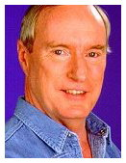
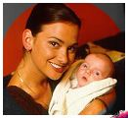
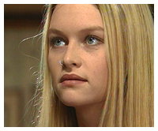
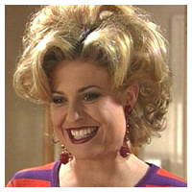
FROM Home and Away
Justine
Chloe
Alf
Marylin

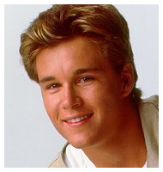

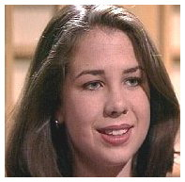
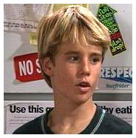
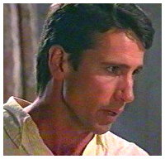
Vinny
Sally
Sam
Joel


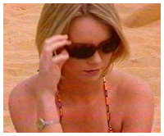
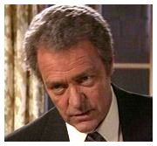
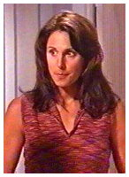
Rebecca
Gypsy
Donald
Natalie

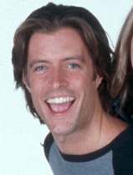


From Neighbours

Amy
Karl
Harold
Dan


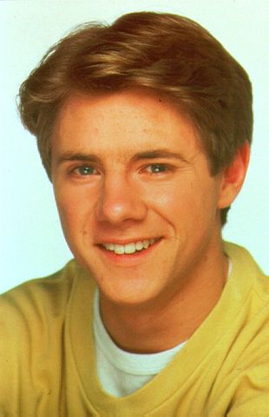



Lance
Libby
Stephanie
Susan


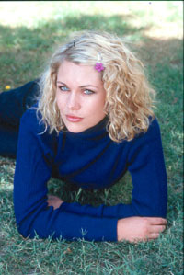
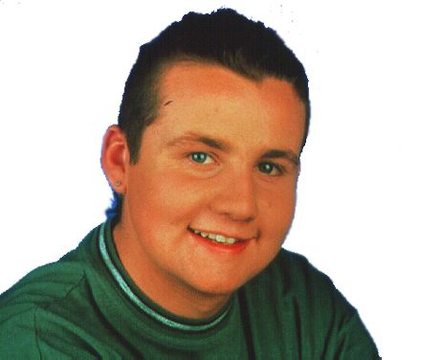
Tad
Tess
Toad

Some of my ideas for A Midsummer Night’s Dream

CHARACTER IN THE PLAY | MY CHOICE | REASON
Puck | Robbie from Eastenders | Robbie is a bit flighty, enjoys a bit of harmless mischief, and often gets it wrong.
Lysander | Vinny from Home and Away | Handsome chap, but not much going on behind the eyes – like both of the male lovers in the Shakespeare play.
Demetrius | Joel from Home and Away | A good contrast with Vinny when the play is staged – like the two female lovers, we have visual contrast to help the audience when the play gets complicated.
Helena | Rebecca from Home and way | The visual difference with Sonia is important here, too. The play also shows a difference between the two female lovers based on appearance and size.
Hermia | Sonia from Eastenders | I think Sonia would be good at the pouting part, as well as being visually right for this.
The Mechanicals | The Battersby family | The mechanicals are daft, often misdirected and comic, and enjoy a bit of an argument. Just like the Battersby family on the Street.
Oberon | Roy from Coronation Street | I’ve made Roy and Hayley Oberon and Titania for comic effect really. They are both capable of the dignity of the parts, and both see things a little differently from the rest of us…  The main thing, though, is that they are a very unusual couple and could carry off the romantic plot of the King and Queen of the fairies very nicely.
Titania | Hayley from Coronation Street

