

DRAMA CASE STUDY 1 – SUPPLEMENTARY RESOURCE 1

THEATRE DESIGN EXAMPLES
(Taken from www.albermarle-london.com)

CONTENTS

The Garrick

The Gielgud

The Globe

The Lyric

The Old Vic

The Royal Shakespeare

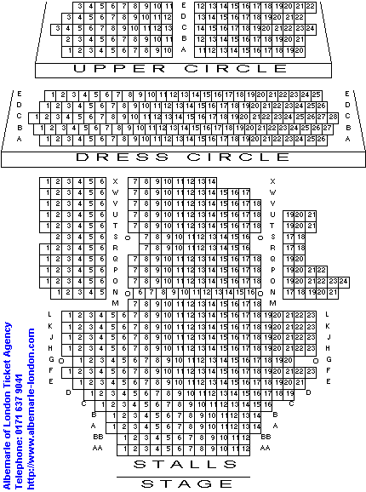

The Garrick

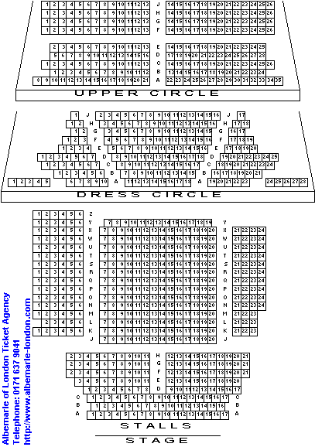

The Gielgud

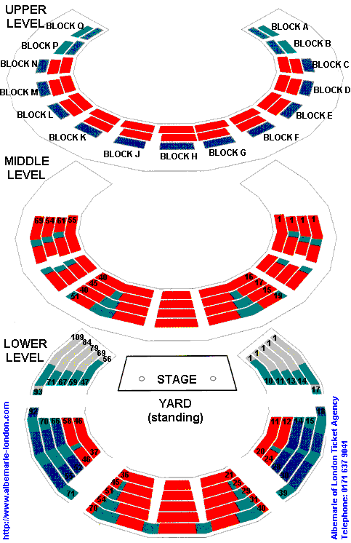

The Globe

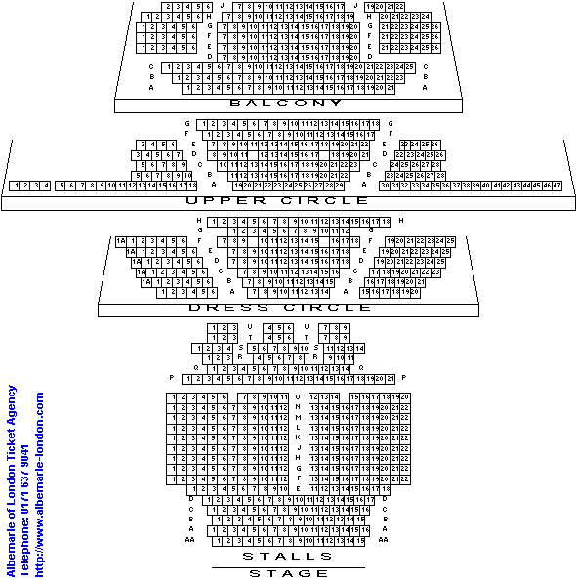

The Lyric

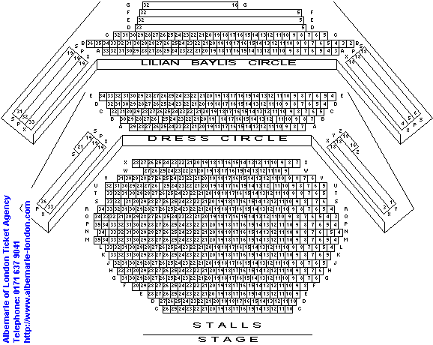

The Old Vic

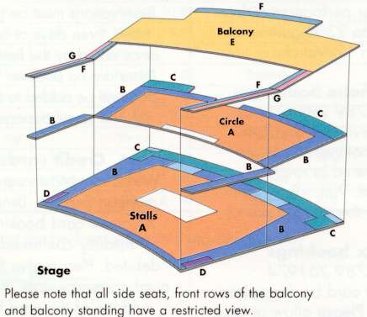

The Royal Shakespeare

