Exploring a Computer Model

Name ___________________________________________________

Part 1
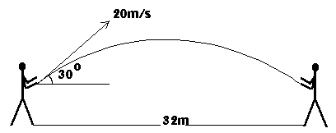

Michelle is trying to throw a ball to David who is 32m away. She throws the ball at an angle of 30o, with a speed of 20 metres per second. Load the spreadsheet BALL2 and type the numbers in to find out how far the ball goes.
Distance:

She can throw faster or slower than this. Change the speed you typed into the spreadsheet to find how fast she should throw the ball so as to just reach David.
Speed:

When you made the speed faster, what happened to the distance?

The fastest Michelle can throw is 30 metres per second. Can she reach Gareth, who is 90 m away?
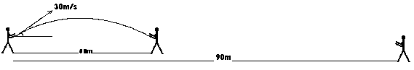

What angle should she throw at so as to just reach him?
Angle:

When you made the angle bigger, what happened to the distance?

