Creating web pages with Front Page Express
Hyperlink
Insert Image

Text Size
Text Colour

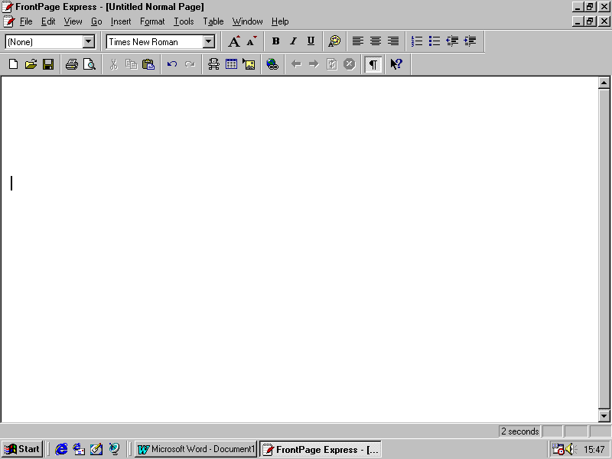
First, give your page a title and save it as follows:
- Choose File, Save As
- Type in a title which describes briefly what the page is, e.g. Group 1 Ambulance Service Home Page
- Click As File then locate the required folder, type in a filename and click Save.

Next, choose the colours you want for the background, normal text, hyperlinks, etc:
- Choose Format, Background and use the options displayed to choose colours.

Then type in the Heading and either the Stem and Options, or the information you want to display.
- To change the size of text, select what you want and use the Text Size buttons.
- To change the colour of text, select what you want and use the Text Colour button.
- To make the options numbered or bulleted, select the options and use the buttons provided.
- To add images, use the Insert Image button as usual.

To make an option into a hyperlink:
- Click on the Hyperlink button
- If you are linking to a page you have already created, choose the Open Pages tab and select its title from the list displayed.
- If you are linking to a page you have not yet created, choose the New Page tab and give the link page a title and filename. Click OK and you will get a blank page to create your link page. To get back to the previous page, choose Go, Back.

