Music Case Study 3 Worksheet
First, take a look at the diagram of the hardware set-up below, and fill in the relevant parts for yourself and your mentor to discuss.

Once you have done this, fill out in the table on the next page the details you are asked for about the way you intend to use your own set-up.

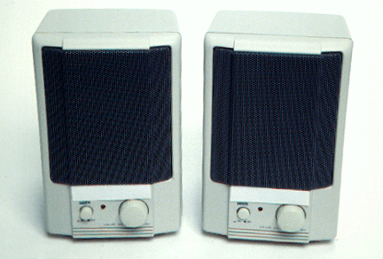


Standard computer-MIDI interface
MIDI device – either the computer’s internal soundcard or a device such as a MIDI keyboard or MIDI sound module
Amp and speakers, or speakers driven by the computer/MIDI device

Computer specs – hardware and software
Sound production details
MIDI device details, including range and capacity for modeling

Pieces of music to be modeled using composition software

Write below three or four examples of pieces you want to work on with pupils | Explain below for each piece the items you will change | For each change you intend to make, describe the differences you expect to encounter in terms of balance – volumes and stereo effects, texture, timbre, flavour, mood and pace | Explain here the benefits to pupils in terms of the development of composition and arrangement skills

