RE CASE STUDY THREE

Copy and Paste from Encarta

STEP 1
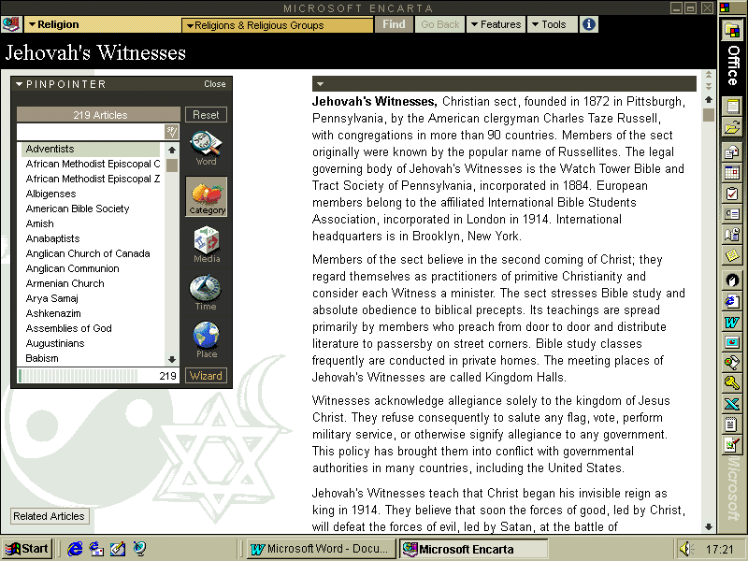
This screen shows my version of Encarta open at the entry on Jehovah's Witnesses

STEP 2
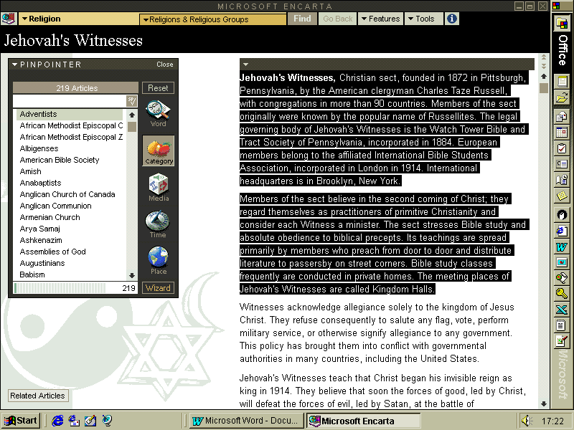
This screen shows a section of text high-lighted - do this by clicking and dragging from the beginning of the selection to the end

STEP 3

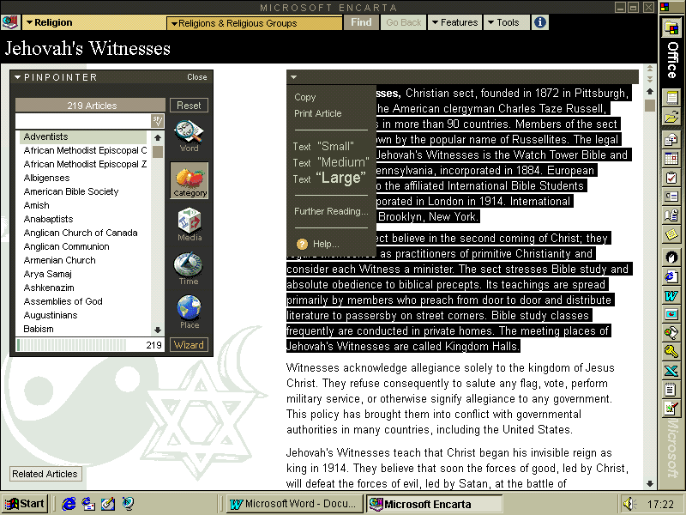
With the selection highlighted, click on the drop-down arrow at the top left of the section of the screen.

It gives you a [Copy] option, which you just click.
With Word open, you now paste the text you have copied into the document by using the drop-down menu, or the paste icon.

STEP 4
