Interactive White
Board Training
Guide – Level 3

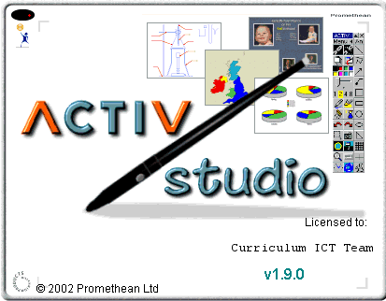


Designed by
space
L. Shaw
C. A. Gerrard
S. Williams

Promethean Interactive White Board Training Guide.
Level 3

Contents

- Default backgrounds

- Adding annotations

- Adding a hyperlink

- Saving individual pages

- Saving images to the library

- Further options

- Flipchart organiser

- Exporting flipcharts

Setting up Default Background

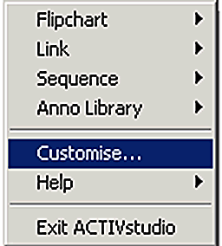
It is possible to set up a background that will appear on all flipchart pages.

Click on Menu on the floating toolbar. Then click on Customise.

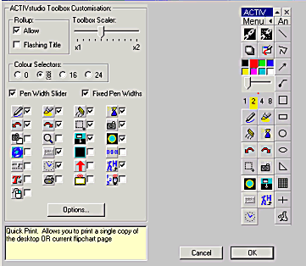

This window will appear.
Click on Options

Click on Flipchart, then Colour to choose a coloured background for all pages. To choose a tile click on Tile.

To see the full tile library click here.
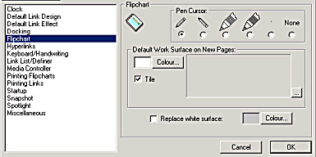

Click OK to finish.

Adding Annotations

Using the freehand pen to draw the annotation you wish to add to the library.
Select the annotation using the Marquee Select tool then right click to display this menu.

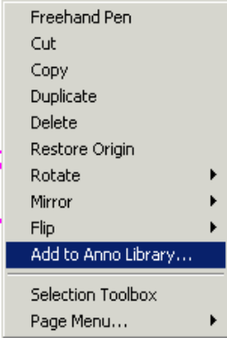

Select Add to Anno Library…

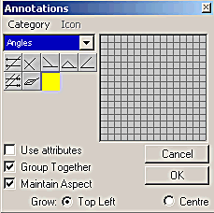
Select the category you wish the annotation to appear in then use the grid to draw a representation of the annotation.

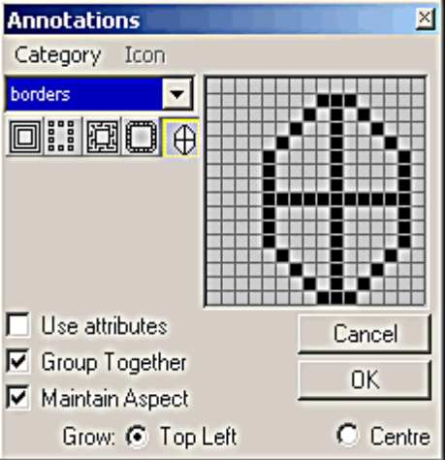

Select OK and the annotation will be added to the library in the category selected.

Adding a Hyperlink

A hyperlink is a way to quickly move from one flipchart page to another, or to a different file, image, video or even a website.

Select the object that is to be used as the link, then right click to display a menu.
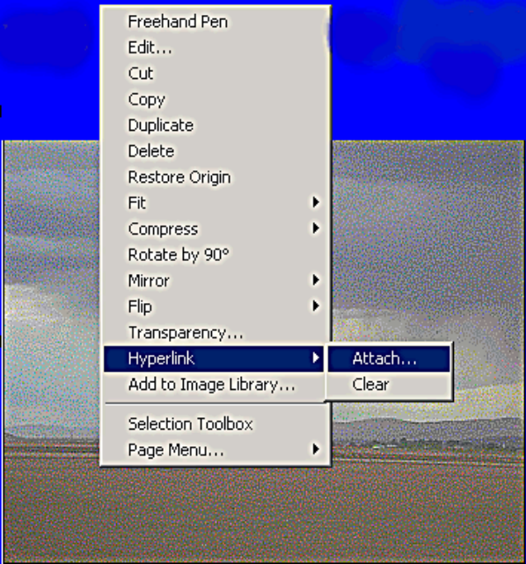

From this menu select Hyperlink then Attach…

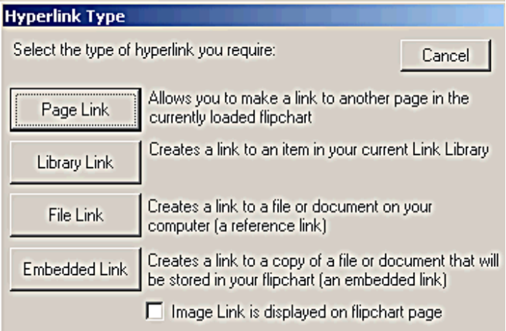
A Hyperlink Type window will appear. Select the type of link required.

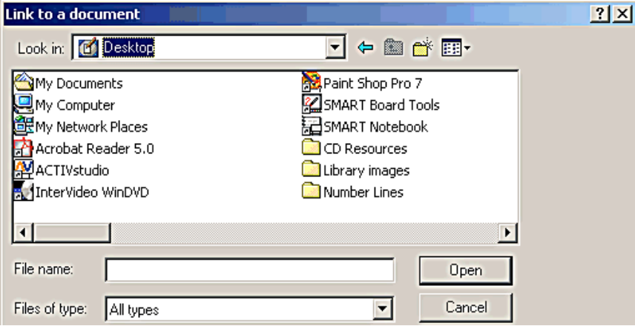
If a file or embedded link is selected a Link to a document window is displayed.

Select the individual file that is to be linked then select Open.

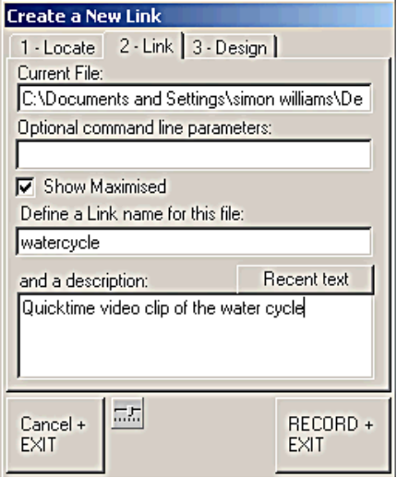
Add a name and a description of the link then select Record and Exit to complete the link.

To activate the link in the
flipchart, you must use the
pen tool.

Saving Individual Pages

Use a right click on a section of the page that has no text, images or annotations to display this menu.
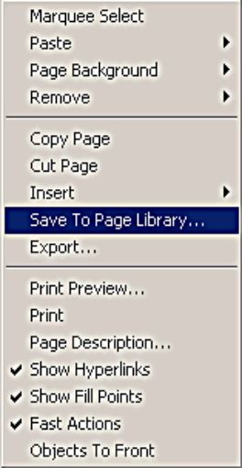

Select Save To Page Library…

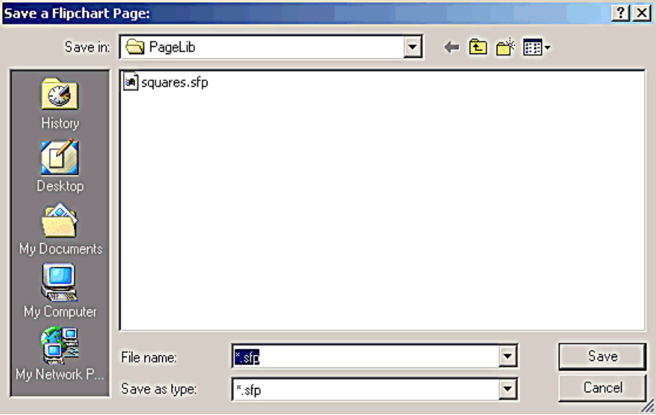
Give the page a file name then select Save.

Saving Images to the Library

Right click on the image to be saved and a menu will be displayed.

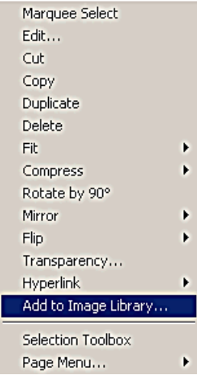
Select the Add to Image Library… option.

The Save an Image window will be displayed.
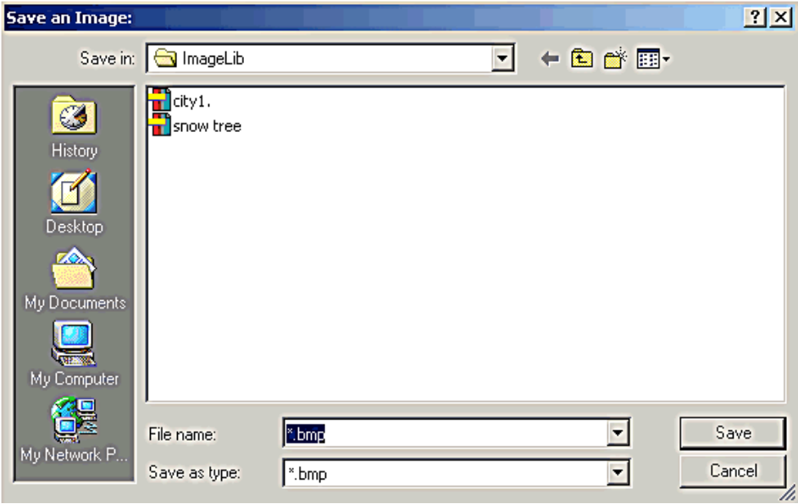

Name the image to be saved and select Save. The image will now be saved in the image library.

Further Options

Many other options may be explored by using the Menu - Customise window.

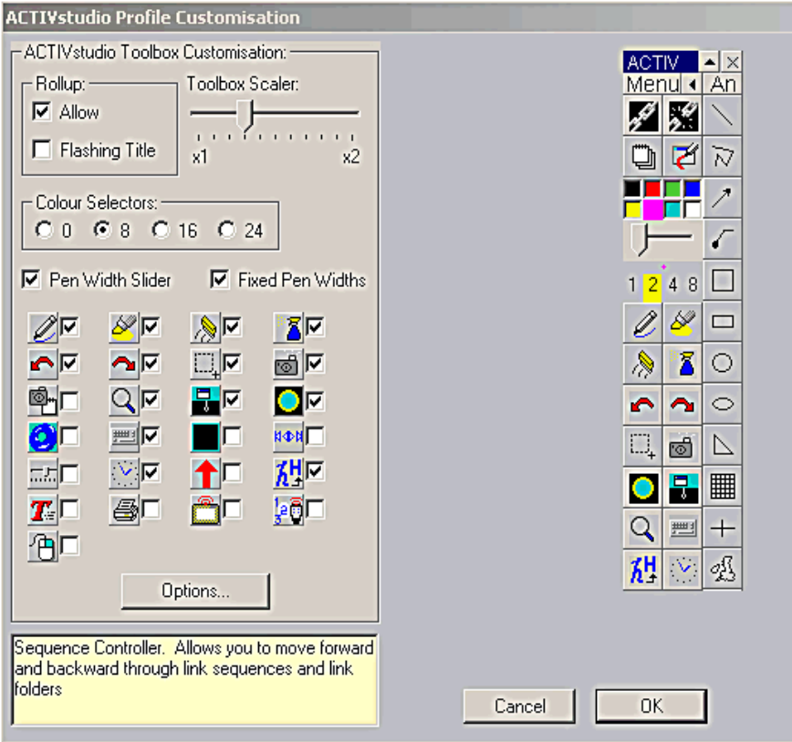

Select options.

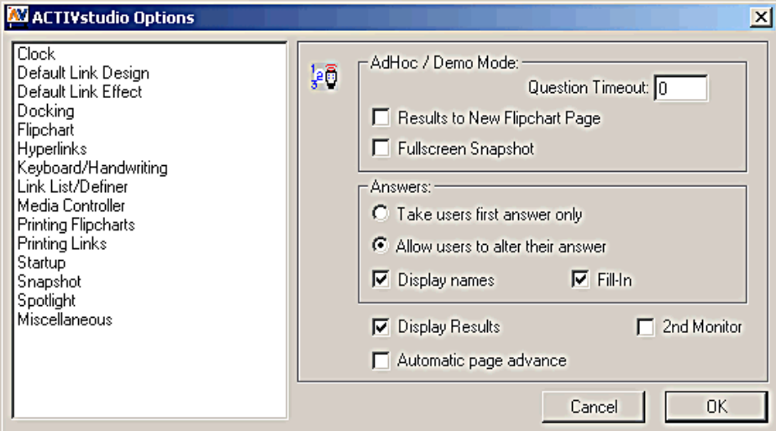

The menu allows for changes to settings on many different Activstudio tools.

Organising flipcharts

It is possible to change the page order of a flipchart or to import pages from a different file.

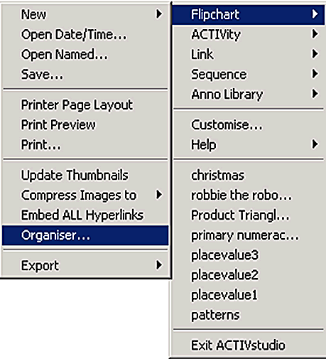
Click on Menu – Flipchart – Organiser and this window will open.

Move pages by dragging to new position.

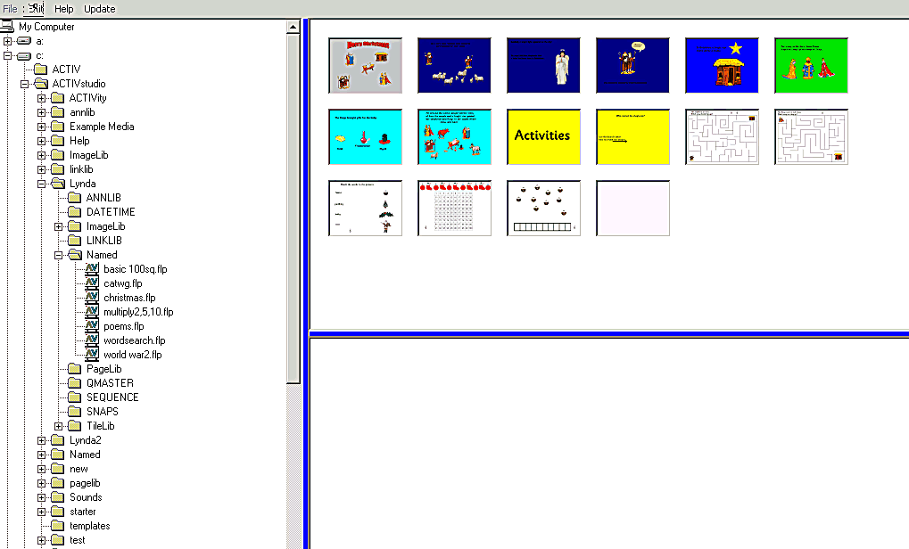

To import pages from a different file load another file from the list on the left.
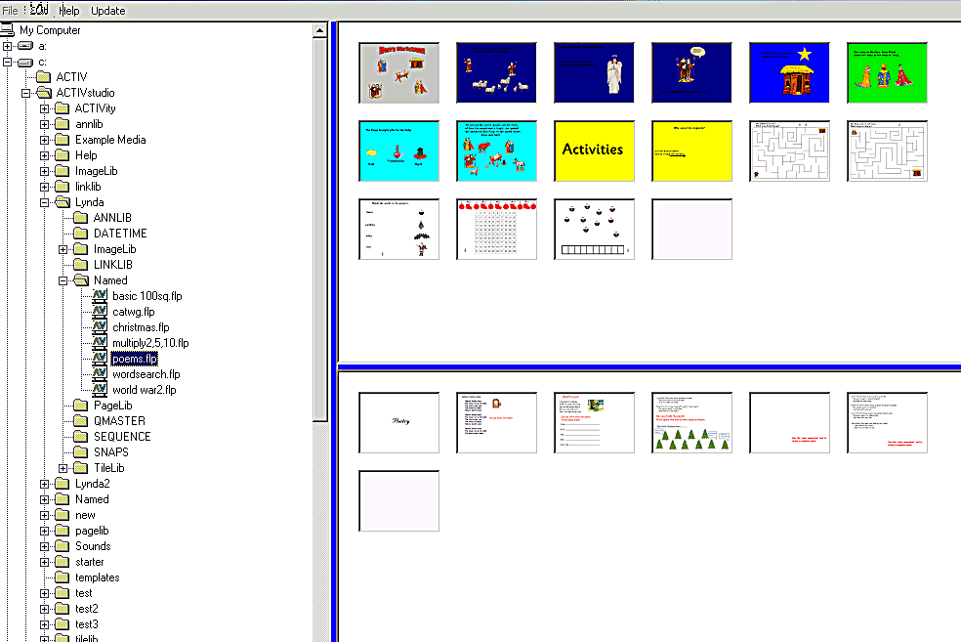

Select a page from the new file and drag into the original flipchart.

Exporting a flipchart as Powerpoint file
It is possible to export a flipchart in different formats e.g. as a Powerpoint file.

Click on Menu – Flipchart – Export – as Powerpoint


